**CHAPTER THREE**

**METHODOLOGY**

**3.1 METHODOLOGY**

This part of the research proposal involves the use of system analysis and design as a tool. it is dedicated to the requirement collection (done with the collaboration of student and bookstore owners), the design of the system, done using UML use cases and class diagrams, and of the relational database, done with EER (extended entity relationship diagram) as modeling technique.

**3.2 SYSTEMS DEVELOPMENT METHODOLOGY**

A system development methodology refers to the framework that is used to structure, plan, and control the process of developing an information system. A wide variety of such frameworks have evolved over the years, each with its own recognized strengths and weaknesses. One system development methodology is not necessarily suitable for use by all projects. Each of the available methodologies is best suited to specific kinds of projects, based on various technical, organizational, project and team considerations.

**3.2.1 SYSTEM DESIGN**

**Rapid application development**

This is a development methodology in which a system designer produces prototypes for an end user. The end user reviews the prototype and offers feedback on its suitability. This process is repeated until the end user is satisfied with the final system. It puts less emphasis on planning tasks and more emphasis on development. It is driven by user interface requirements.

**RAPID APPLICATION DEVELOPMENT**

**REQUIREMENT**

**PLANNING**

**DESIGN PHASE**

**CONSTRUCTION**

**CUTOVER**

**Figure 3.1 stages of RAD()**

**Requirement planning**

This phase is similar in concept to the traditional analysis phase. However, the nature of planning when constantly reviewing prototypes means that it is often revisited within what would traditionally be regarded as design and implementation. Rather than the client working with the systems analyst to devise a software specification, the client is continually involved in reviewing the design and related prototypes that are generated throughout the process. This can result in alteration to the client’s requirements. It is often the case that clients have little or no technical awareness. Only when they see prototypes of different elements of the system during the subsequent design are better prepared to firm up and finalize the requirements that they may have had during a traditional analysis phase. Often requirement planning focuses on planning for a range of prototypes.

**Design phase**

Once the clients initial needs have been determined, the software development team will invest as much as they can in generating prototypes that can be taken back to the client for refinement. This avoids situations where the client agrees with a proposal on paper but then disagrees with the software that has been generated over a long period of time which can happen when using the waterfall method. It is usual for some crossover to exist between design and implementation. It is only possible to construct a prototype of elements of the system if there has been some degree of implementation.

**Construction phase**

Within the construction phase, the programmers take the preferred prototypes and begin to  
construct a formal solution. This is naturally involves implementation and will focus on aspects of the software that were not part of the prototypes shared with the clients such as those that have been time boxed. The advantage if having already designed prototypes is that some of the implementation may have been complete already. As with all aspects of RAD, the client can be involved if necessary. This would be likely during testing.

**Cutover phase**

One the construction and in house testing has been completed, the project moves into the cutover phase. Within this phase the client and the client’s staff will be using the software as normal. The development team will remain available for a predefined timescale to carry out corrective maintenance, incorporating feedback from the client in relation to the client’s evaluation of how the software operates in real context. This phase is regarded as streamlined and concise equivalent of traditional evaluation and maintenance.

**Justification of RAD Faster delivery time**

This is achieved by rapid prototyping and by using automated tools like Computer Aided Software Engineering of CASE tools that enable the developers to re-use previously generated codes thus saving time needed for manual coding.

**Better quality**

Although RAD may imply some compromise in terms of scalability and the range of features in the product been delivered. It enhances the product quality by providing a considerable reduction in the errors due to the use of automation tools and prototyping. Errors and omissions are detected in the early stages of development therefore preventing any extra effort and cost.

­

**Reduced risk**

Due to the iterative approach and prototyping, testing and integration of end user feedback  
happens at each stage of development. Hence, the end products have less number of defects and changes, thereby minimizing the risks involved in the project. There is little or no testing effort involved.

**3.3 SYSTEM REQUIREMENT ANALYSIS**

Requirements analysis process is an important stage in the system development. It determines the functions of the whole system integrity and stability. Software requirements analysis is an ongoing process of understanding and progressive refinement. Through requirements analysis, functions of the online bookstore system will be designed as below.

**3.1. Requirements Gathering**

The purpose of project is to create an online bookstore system.

**3.1.1. Requirements**

The online bookstore system carries out many functions. The most important functions are  
books sales, manage books, and manage shopping carts. In addition, the one more function  
of system also needs to provide to customers to search relational books in the database. At the same time, making sure trading books, the system must verify the customer identity.

Finally the system must have administrator’s functions, which allows administrator operates and maintain back end database. Overall according to the online bookstore system functional requirements, the system falls into the front management application and back-stage management application. The front management application is the user visits online bookstore website and register user is customer. Only customer manages his/her account and shopping cart. So in this part, specific functions are described as below:

* Login and logout.
* Register
* Browse books (base on category list, or input keywords to search books).
* Add book to shopping cart.
* Handle shopping cart.
* Order books
* Payment methods
* Update account information.
* Recommendation
* Forget password

The back-stage management application is manage by the staffs manage. Stock manager’s responsibilities are book management, administrator’s responsibilities are order management and customer’s management. So in the staff part, specific functions are described as below:

* Login and logout
* Add/delete/modify account
* Handle order
* Stock manager manage books

**3.2. SYSTEM ARCHITECT**

In this chapter, high levels and detail levels designing are given.

**3.2.1. HIGH LEVELS FOR FIVE MODULES**

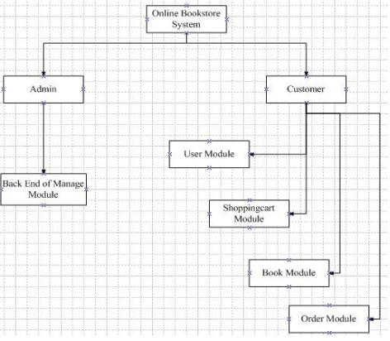According to requirements gather, the online bookstore system will be designed that consists of five basic modules. The diagram is as follow:

Fig 3.1 **Five modules of the online bookstore system**

**USER MODULE**

At first customers must login or register to the system. Customers can purchase books  
after validate valid identity. Customers can modify their own account information at  
any time. When customers register successful, the online bookstore system will save customers’ all information. One more function, when customers forget their password, they can click on ”forget password” link to get back password.

**BOOK MODULE**

The function of book module is to show all of books. When customers enter online  
bookstore books website, they can view a list of all books categories and subcategories.  
The system sorts books, customers browse all kinds of books as needed. Customers  
can view books detail information. Also the system recommends books for customers. Stock managers list book detail information, view all book lists, delete and modify  
book information.

­­

**SHOPPINGCART MODULE**

The core of online bookstore system is shoppingcart module. The module is to  
simulate people purchase goods in supermarket used shoppingcart. The online  
bookstore of each customer has their own shoppingcart. Customers click on the picture  
of book or title to purchase books. The shoppingcart will automatically add the  
bookname, price and other information. At the same time, customer can delete book or  
edit book quantity as needed. Shoppingcart module automatically calculates and  
display totalprice. The customer just only press ”checkout” button, the system will  
automatically store the purchase information input back end database. In order to  
administrator to manage orders.

**ORDER MODULE**

The Checkout button in shoppingcart moves customer to order module. At first,  
order module lists books in shoppingcart. It includes books detail information, as book  
title, price, quantity, item totalprice and total price. When customers confirm them,  
they will fill in shipping information about consignee detail information and payment  
methods. Then customers press checkout button to place order.

­­

**BACK END OF MANAGE MODULE**

Here is back end database of manage books module. When administrators or stock  
managers input ID and password, the system verify identity. The module functions are  
categories manage, add new book information, modify and delete specific book  
information.

**3.2.2. DETAIL LEVELS DESIGNING**

**3.2.2.1. SITEMAPS OF THE ONLINE BOOKSTORE**

The purpose of sitemaps is to show what functions the online bookstore system  
architecture has.

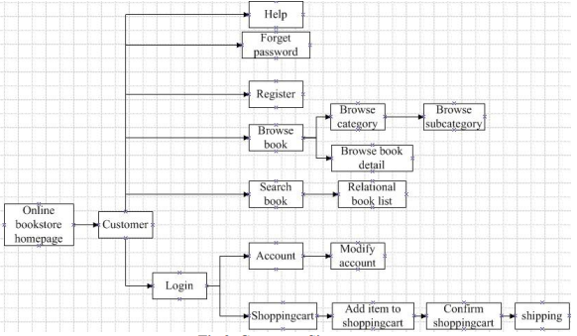

**Fig.3.2. Customer Sitemap**

Fig.3.2 shows how a customer enters the online bookstore homepage, he/she can view top  
menus: login, register, books, shoppingcart, account, and help. Customer clicks on  
categories or subcategories books to read books detail information. Also customer can  
search books. When customer logins successful, he/she manages his/her shoppingcart to  
place orders and manages account information.

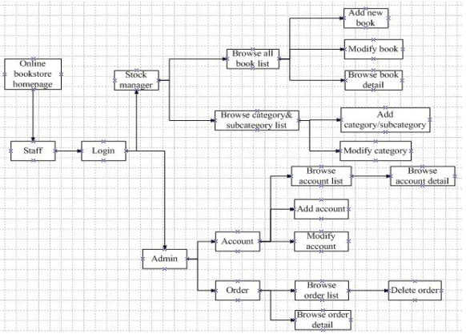

**Fig.3.3. Staffs Sitemap**

Fig.3.3 shows staffs manage back end database system. Stock manager’s responsibilities are to view all books list, browse categories and subcategories list and manage books  
information. Administrator’s responsibilities are manage customers’ accounts and orders.

**3.2.2.2. Flow of Customer Diagram**

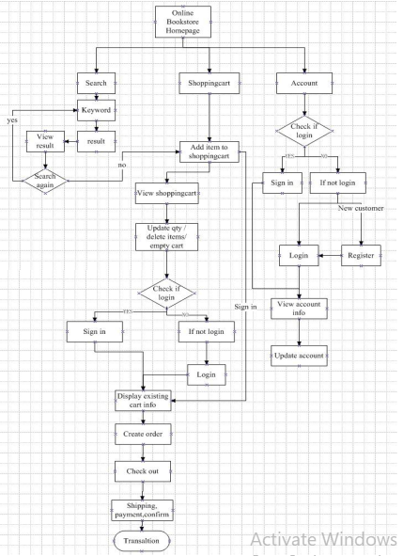

**Fig.3.4. Process diagram of customer searches, shopping cart, account**

Fig.3.4 diagram describes the whole process of customer searching books and purchasing  
books. There are main functions are customer login, register, search books, purchase books and place order.

* Customer chooses or searches interesting books and puts them into his/her shopping cart.
* Customer must be registered at first. Only after customer logins the online bookstore system, he/she can place orders.
* Customer fills in shipping form, confirms information and submits the purchase orders, after he/she chooses books.

**3.3. USE CASES**

**3.3.1. COMMON FUNCTIONS**

**Login**

Every time user logins the customer or administrator application, he/she must input  
both of the correct account ID and the password into the input-form. The  
application will get the input data and send to the System Server, and the server  
will communicate with the Database and check whether the account ID and  
password are matched. If it is correct, the application will display the WelcomeWindow, and then switch to the Member Information Interface. Otherwise, the Error-window will be instead. After that, the application will turn back to the login interface.

**Logout**

This functionality works when the user selects the “Logout” menu, the application  
will be closed and return back homepage.

**3.3.2. CUSTOMER FUNCTIONS**

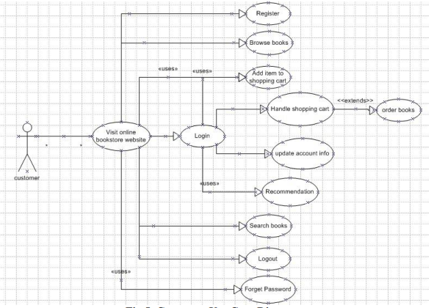

**Fig.5. Customer Use Case Diagram**

**REGISTER**

Firstly, new customers need to register to get one account ID. Information which  
should be included: customer name, password, email address, phone number and  
address information. After registration, customers will get an account ID and they  
can login with account ID and password. The application will insert all the information into the corresponding database tables.

**BROWSE BOOKS**

Customers can choose interesting books from categories or subcategories.  
Customers click on the book link. They can browse specific book information as: book name, price, and picture, abstract and so on.

**HANDLE SHOPPING CART**

Customers manage their shopping cart. Each shopping cart has exactly one  
customer. Customers can edit specific book quantity, or delete specific books in  
shopping cart, or empty shopping cart.

**ORDER BOOKS**

When customers login the shopping cart website, they confirm items and press  
“processed to checkout” button, the system will request customers fill in shipping  
form. The shipping form includes first name, last name, address, city, post and  
phone. When customers finish form, they choose payment method for next process.  
If customers are not logged in or unregistered, the purchase function will not work.

**UPDATE ACCOUNT INFORMATION**

Only registered customers can update his/her account information. After login  
successful, customers can change private information, like that address, password and so on. When they press submit button, the system will update and store the corresponding database.

**SEARCH BOOKS**

All users can use the search engine. Users input keyword in search engine, and  
click on the “GO” button. The system will search books from the relational  
information in database. If there are matched books existing, the results will be listed on search page. Or else the search page will display no matched book.

**3.3.3. Administration Functions**

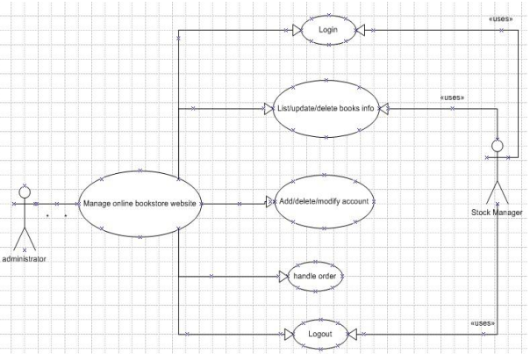

**Fig.3.6. Administrator Use Case Diagram**

**Add/delete/modify/view accounts**

On the account page of administration, the administrators can directly add or delete  
or modify or the customers’ accounts. It includes customer’s private information as his password, address and so on. Also administration can view all accounts list.

**Handle order**

Administrators login the handle order website, they browse all customers’ orders.  
There are “detail and delete” buttons after every ordering. After the administrators  
click on specific customer’s “detail” button, they can view the specific customer’s  
orders information. Such as order ID, book ID, quantity and so on. Also,  
administrators delete specific customer order. One more function is that administrators press “deliver” button to change order state.

**Stock manager**

Another type of administrator is stock manager. Stock managers can handle book  
information as list books detail information, modify or update existing quantity  
and price, add and delete books into stock.

**3.4. The Main of Sequence Diagrams**

In this chapter, there are some more important of sequence diagrams. It includes customer  
part, stock manager part and administrator part.

**3.4.1. Customer Sequence Diagrams**

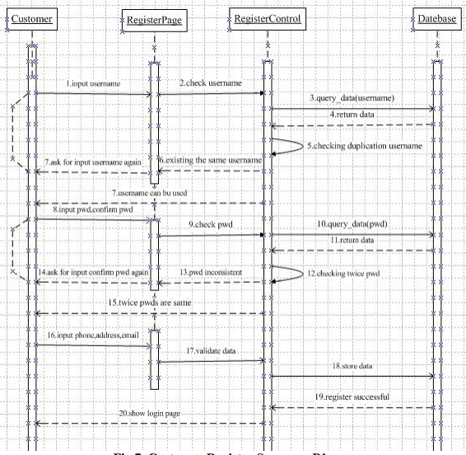

**Fig.3.7. Customer Register Sequence Diagram**

Fig.3.7 is drawn to describe the customer registers for new account on the online bookstore  
website. The new customer enters the website, and selects the “register” top menu. He/she  
inputs username, the application will check whether the username is valid or not, for  
instance the duplication username. If there is the same username, the application asks  
customer to inputs new username again. When username is passed, customer continues to  
fill in password and confirm password again. The application checks passwords twice from  
database. If passwords are inconsistent twice, the application asks for customer inputs  
confirm password again. Since the passwords are matched, customer will be allowed to fill  
in the rest of form as phone, address and email. The customer finishes the register form and submits it. The application will validates the entered data, then send to the system server to store customer information in account ID.

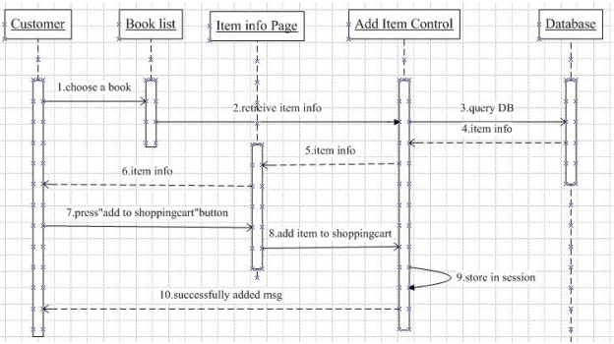

**Fig.3.8.Customer Add Item to Shoppingcart Sequence Diagram**

Fig.3. 8 is drawn to describe the customer adds books to his/her shopping cart. When  
customer enters the books website, he/she can choose an interesting book form books list.  
The application will retrieve book information from database to show it on the book detail  
information page. After that, customer can presses “add to shopping cart” button, the  
application auto adds the book to shopping cart and stores in session. At the end,  
application will send successfully added message on website.

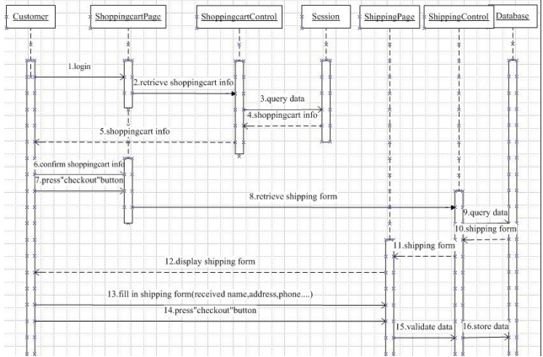

**Fig.3.9. Customer Place Order Sequence Diagram**

Fig.3.9 is drawn to describe the flow of customer places order. The customer must be login  
successfully on the shopping cart page. The application will retrieve his/her shopping cart  
detail information to show it to customer. Customer confirms shopping cart information,  
then presses “checkout” button. Next customer must fill in shipping form about received  
name, address and phone information, then presses “checkout” button again. The  
application will validate data and store it.

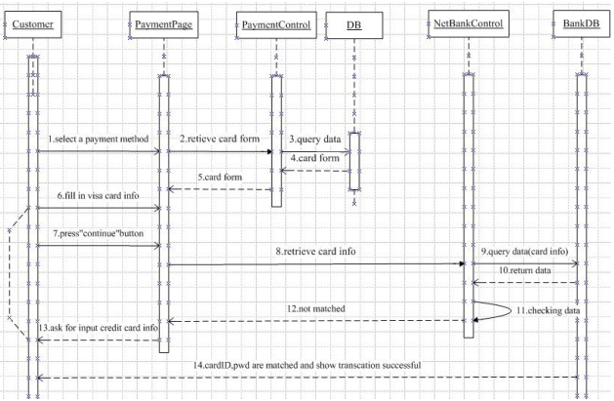

**Fig.3.10.Customer Payment Sequence Diagram**

Fig. **3.10** is drawn to describe the flow of the customer selecting payment method after he/she finishes shipping form. When customer chooses just only one payment and fills in visa card information, he/she presses “continue” button. The application will check card  
information. If card information not matched, it asks for customer inputs credit card  
information again. When card ID and password are matched, the application will show  
transaction successful to customer.

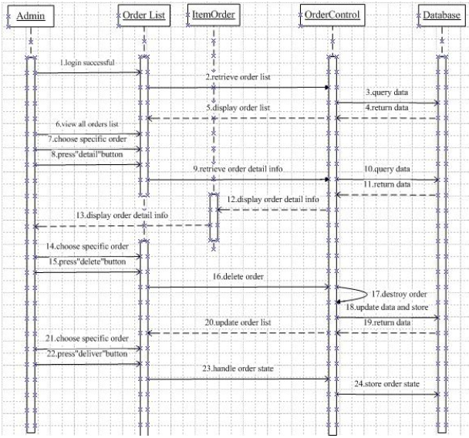

**Fig.3.11. Administrator Handle Order Sequence Diagram**

Fig.3.11 is drawn to describe the flow of how administrator handling order. The  
administrator must be login successfully to handle order website. He/she can browse all  
customers’ orders. There are “detail and delete” buttons after every order. The  
administrator chooses specific order and presses “detail” button. The application will  
display the order detail information. If administrator presses “delete” button, the  
application will destroy order from database and update database then store it. The order  
list page will update. When administrator chooses specific order, then he/she presses  
“deliver” button. The application will handle order state and store order state in database.

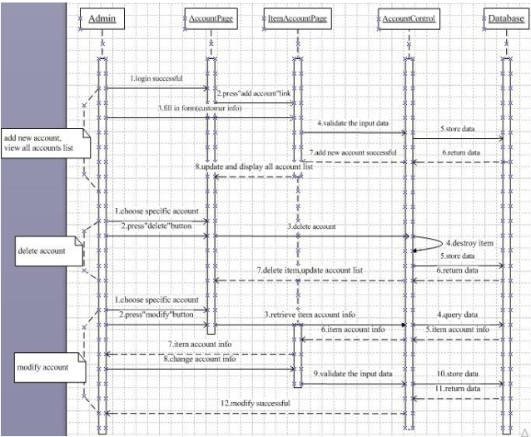

**Fig.3.12. Administrator Manage Account Sequence Diagram**

Fig.14 is drawn to describe the process of how administrator manages account. At first,  
the administrator must be login successful on account website. When administrator clicks  
on “add customer account”, he/she fills in the form about customer information and  
submits it. The application will validate the entered data and send to the system server. If  
the administrator chooses specific account will be deleted, then presses “delete” button.  
The application will destroy account from database and update database. The website auto  
switches to account list. If administrator chooses specific account, and he/she wants to  
modify account information, then he/she presses “edit” button. The application will display  
account information from database. Then administrator changes some information and  
presses “submit” button. The application sends data to the system server and stores again.  
Also, it shows modify successful message on account detail page.

**4.0 DESIGN DATABASE**

Database plays an important role in the information management system. The structure of  
database will directly affect the efficiency of system and achievement of results. The good  
database structure design can improve the efficiency of the data storage, make sure data  
integrity and consistency.

**4.1 Design Database Tables**

According to the entities set and relationship of requirements analysis, online bookstore  
database designs seven tables. There are customer table, order table, order_item table, book  
table, category table, subcategory table, and staff table. As follow:

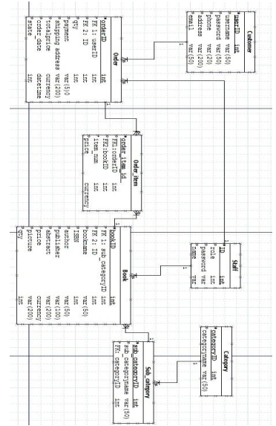

**Fig.3.13 Online bookstore database diagram**

**3.5 HARDWARE AND SOFTWARE REQUIREMENTS**

**3.5.1 HARDWARE REQUIREMENTS (MINIMUM)**

**Server side**

|  |  |
| --- | --- |
| Processor | 2.20 GHz |
| Ram | 2 GB |
| Hard disk | 10 GB Free Space |

**Client side**

|  |  |
| --- | --- |
| Processor | 2 GHz |
| Ram | 1 GB |
| Hard disk | 4 GB Free Space |

**3.5.2 SOFTWARE REQUIREMENTS (MINIMUM)**

**SERVER SIDE**

|  |  |
| --- | --- |
| Operating system :- | Windows server 2003 or any compatible server OS |
| Framework | Net framework 4.6 |
| Web Server | IIS 8.0 |
| Front End | ASP. NET MVC with C# (.NET) using Visual Studio 2017 |
| Back End | SQL server 2014 with Microsoft SQL Management Studio |

**Client side**

|  |  |
| --- | --- |
| Operating system | Windows XP or any compatible OS |
| Browser | Google Chrome, IE, Opera and FireFox |